**Day-6 session-6(19/08/2024)  
Step-1:** Connect to the server and usedefault username and password

**Username:** **ec2-user**

**Password**: **DevOps321**

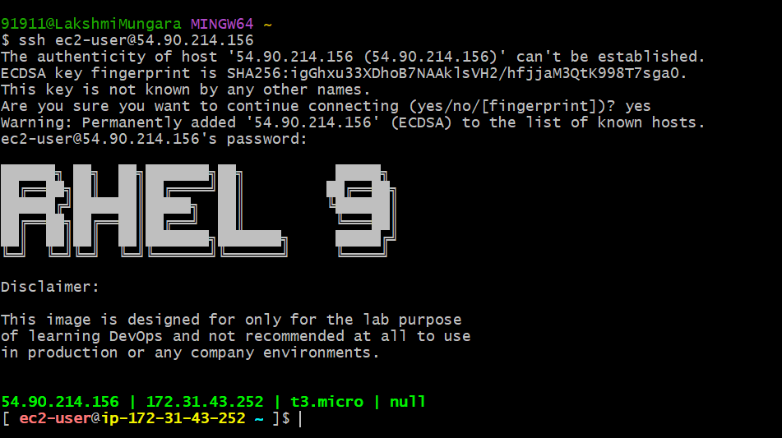

**Step-2**: Go to root directory and install the mysql-server by using the command,   
 dnf install mysql-server -y

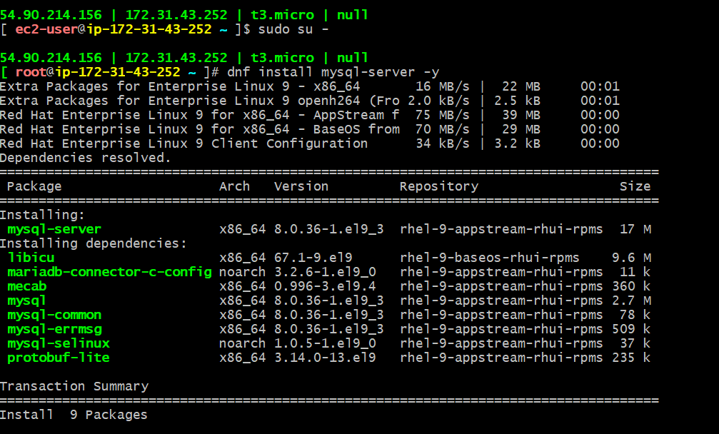

**Step-3**: Start the mysql and check the status

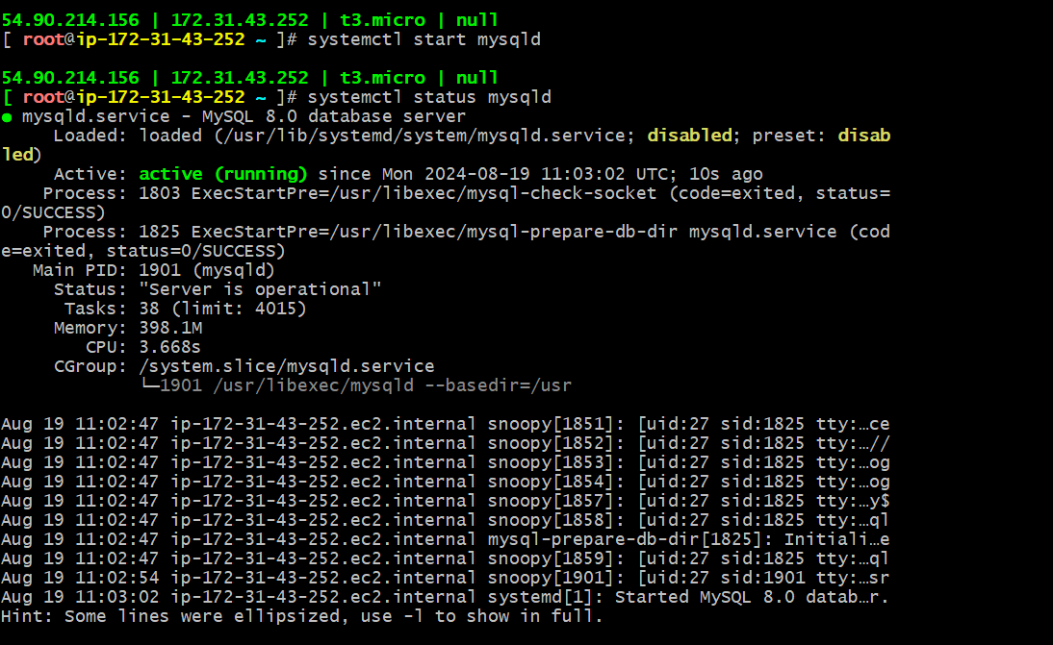

**Step-4**: Check the port number 3306 is opened or not

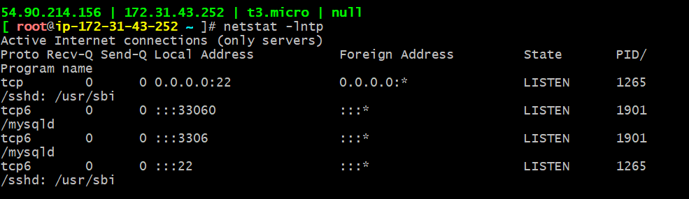

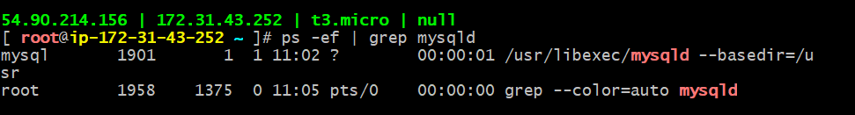

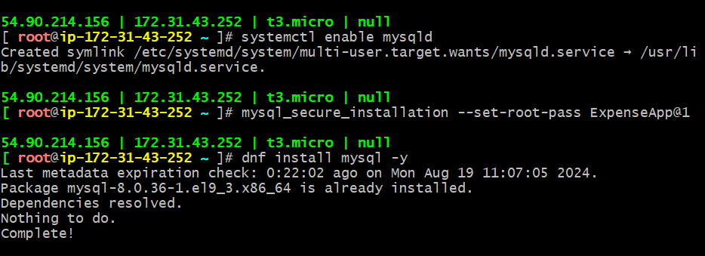

**Step-5:** Enable the mysql, enter the command mysql to begin the database and show the databases which are availabe

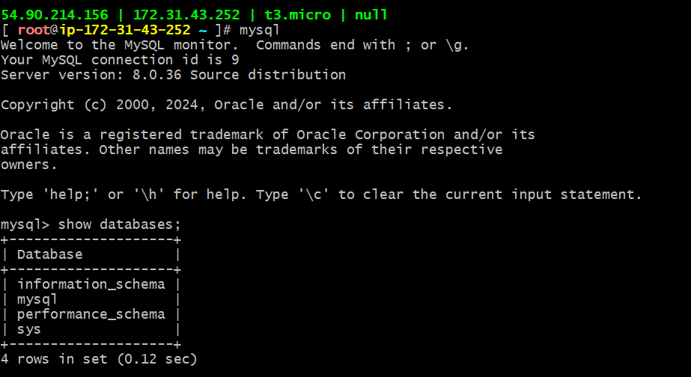

* Use any of the Database from the above

